**Practical Number 13: Build a web page using AJAX Controls.**

**1st Program: AJAX UpdatePanel Example (Partial Page Update)**

This program updates the **current time** without refreshing the entire page.

**Steps:**

1. Create an **ASP.NET Web Forms** project in **Visual Studio**.
2. Add a new **Web Form** (WebForm1.aspx).
3. Copy the following code.

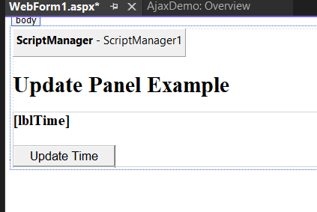

**Frontend:** WebForm1.aspx

<%@ Page Language="C#" AutoEventWireup="true" CodeBehind="WebForm1.aspx.cs" Inherits="AjaxDemo.WebForm1" %>

<!DOCTYPE html>

<html lang="en">

<head runat="server">

<title>AJAX UpdatePanel Example</title>

</head>

<body>

<form id="form1" runat="server">

<asp:ScriptManager ID="ScriptManager1" runat="server"></asp:ScriptManager>

<h2>Update Panel Example</h2>

<asp:UpdatePanel ID="UpdatePanel1" runat="server">

<ContentTemplate>

<asp:Label ID="lblTime" runat="server" Font-Bold="True"></asp:Label>

<br /><br />

<asp:Button ID="btnUpdate" runat="server" Text="Update Time" OnClick="btnUpdate_Click" />

</ContentTemplate>

</asp:UpdatePanel>

</form>

</body>

</html>

**Backend: WebForm1.aspx.cs**

using System;

using System.Collections.Generic;

using System.Linq;

using System.Web;

using System.Web.UI;

using System.Web.UI.WebControls;

namespace AjaxDemo

{

public partial class WebForm1 : System.Web.UI.Page

{

protected void Page_Load(object sender, EventArgs e)

{

if (!IsPostBack)

{

lblTime.Text = "Last updated time: " + DateTime.Now.ToString("HH:mm:ss");

}

}

protected void btnUpdate_Click(object sender, EventArgs e)

{

lblTime.Text = "Last updated time: " + DateTime.Now.ToString("HH:mm:ss");

}

}

}

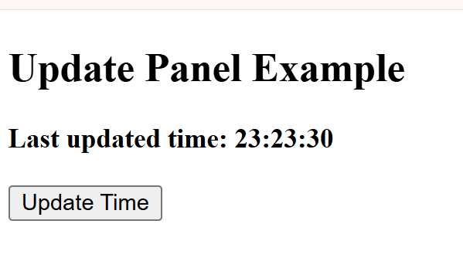

**2nd Program: AJAX Timer Example (Auto Refresh without Full Page Load)**

This program **automatically updates the time every 5 seconds** using an AJAX **Timer Control**.

**Steps:**

1. Add another Web Form (TimerDemo.aspx).
2. Copy the following code.

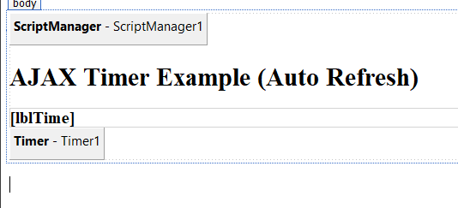

**Frontend: WebForm2.aspx**

<%@ Page Language="C#" AutoEventWireup="true" CodeBehind="WebForm2.aspx.cs" Inherits="AjaxDemo.WebForm2" %>

<!DOCTYPE html>

<html lang="en">

<head runat="server">

<title>AJAX Timer Example</title>

</head>

<body>

<form id="form1" runat="server">

<asp:ScriptManager ID="ScriptManager1" runat="server"></asp:ScriptManager>

<h2>AJAX Timer Example (Auto Refresh)</h2>

<asp:UpdatePanel ID="UpdatePanel1" runat="server">

<ContentTemplate>

<asp:Label ID="lblTime" runat="server" Font-Bold="True"></asp:Label>

</ContentTemplate>

</asp:UpdatePanel>

<asp:Timer ID="Timer1" runat="server" Interval="5000" OnTick="Timer1_Tick" />

</form>

</body>

</html>

**Backend: TimerDemo.aspx.cs**

using System;

using System.Collections.Generic;

using System.Linq;

using System.Web;

using System.Web.UI;

using System.Web.UI.WebControls;

namespace AjaxDemo

{

public partial class WebForm2 : System.Web.UI.Page

{

protected void Page_Load(object sender, EventArgs e)

{

if (!IsPostBack)

{

lblTime.Text = "Current time: " + DateTime.Now.ToString("HH:mm:ss");

}

}

protected void Timer1_Tick(object sender, EventArgs e)

{

lblTime.Text = "Updated time: " + DateTime.Now.ToString("HH:mm:ss");

}

}

}

